The point of this project was to create an AI that would be able to play against a player
Xess
Main Focus: AI
Michael Pansegrauw
2021
Current Unity Version for project files: 2021.2.6f1

Table of Contents
Xess 2
Game Rules 2
Piece Move rules 2
Game Ending Conditions 2
Game State representation 3
Pieces 3
Board 4
Adhoc AI 5
Figures 5
Changes to Utility function 7
Game Utility Function 8

Xess
Xess (pronounced Z-ess) is a two-player turn-based strategy game. The goal of the cam is to use strategy to eliminate the enemy commander or all their forces without losing your own forces or commander.

Game Rules
Each player moves one piece per move until the game ends.

Piece Move rules

Pawn Move Rules
- Can only move one tile diagonally at a time.
- Can not move Backwards in any way.
- Can take any piece on the tile directly in front of it.

Supporter Move Rules
- Can only move diagonally 2 tiles.
- Can take pieces diagonally 2 tiles.
- Can take pieces directly diagonally of the piece.

Commander Move Rules
- Can move to any directly adjacent tile and directly adjacent tile.
- Can take any directly adjacent piece and directly adjacent piece.

Game Ending Conditions

Win Condition
- Taking the opponents commander.

Draw Condition
- If there are only commander pieces left.

Loss Condition
- Losing all pieces aside from the commander and failing to take a piece with in 10 moves.

Game State representation

Pieces
Each piece will extend from a parent class named Piece. This makes it easier to make use of methods with in the pieces. The parent class will contain variables to store the team the pieces is on. The Piece parent class will also contain a constructor that will accept the team the piece is on and abstract methods Type(), and CheckMoveType() and a normal method Team(). Each class related to the pieces will be Serializable
Team() will simply return what team the piece is on.
Type() will be an abstract method that will be used to return the type of piece the piece is. Each piece class will return their own piece type.
CheckMoveType() will be an abstract method that will accept two board positions . The first board position will be the piece’s current position and the second position will be the targeted move position the player chose. The method will then decide what type of a move(s) (take or move or both) can be done to reach the second board position or it will return a move fail.

Example of Piece
[System.Serializable]
public class Pawn : Piece
{
public Pawn(TypeTeam _team) : base(_team)
{
}

public override MoveType CheckMoveType(int[] pos1, int[] pos2)
{
if (team == TypeTeam.RED) // Red piece => moves forwards
{
if (pos1[0] < pos2[0])
{
if (pos1[0] + 1 == pos2[0] && pos1[1] == pos2[1])
{
return MoveType.TAKE; // move type for this position is take
}
else if (pos1[1] + 1 == pos2[1] || pos1[1] - 1 == pos2[1])
{
if (pos1[0] + 1 == pos2[0])
return MoveType.MOVE; // move type for this position is move
}
}
}
else // Blue piece => moves backwards
{
if (pos1[0] > pos2[0])
{
if (pos1[0] - 1 == pos2[0] && pos1[1] == pos2[1])
{
return MoveType.TAKE; // move type for this position is take
}
else if (pos1[1] + 1 == pos2[1] || pos1[1] - 1 == pos2[1])
{
if (pos1[0] + 1 == pos2[0] || pos1[0] - 1 == pos2[0])
return MoveType.MOVE; // move type for this position is
}
}
}

return MoveType.FAIL;
}

public override TypePiece Type()
{
return TypePiece.PAWN;
}
}

Board
The board will be represented with a two-dimensional array of pieces to represent the board. This way the board will be able to be interpreted easily for artificial intelligence. The Board class will also contain the length and width of the board for the use of other classes. The game will be saved as a series of moves that the game engine can then go through to retrieve a saved board. The Width of the board will be show to the player with letters and the length of the board will be numbers.

Example of a board representation
Key: E = Empty, P = Pawn, S = Supporter, C = Commander
Piece Board = {
{E, S, S, C, S, S, E},
{E, P, P, P, P, P, E},
{E, E, E, E, E, E, E},
{E, E, E, E, E, E, E},
{E, E, E, E, E, E, E},
{E, E, E, E, E, E, E},
{E, E, E, E, E, E, E},
{E, P, P, P, P, P, E},
{E, S, S, C, S, S, E},
}
This is a representation of a typical board layout for the default board settings

Random Board Layout
The board is randomised in a way whereby each player is assigned the same number of random pieces in the same shape. Each player is still only allowed one Commander and it is always placed in the middle of the formation. When a random board layout is chosen the Board colours are assigned by use of Perlin noise to assign the red, green, and blue colours to each of the tiles resulting in pleasant looking board colours.

Adhoc AI
The adhoc AI type used in Xess (the game) is a Finite State Machine. The general behaviours of the AI include progressing the game, evading loss, and winning the game. Because of the complexity of the game a Tree Search based AI would not have enough depth to always make a move that will positively impact the outcome of the game for the AI. On top of that the utility function gives enough data to use in a Finite State Machine to create an AI that can pose as a good opponent for a human player. A Finite State Machine also uses less resources. Further more this type of AI can be an effective training partner for a neural network based AI as it can run extremely fast so a lot of training can be done to improve the neural network.
When trying to close the game the AI will seek to take the enemy Commander withing 1 move. [figure 1] The AI will cycle through points assigned to each piece using the Utility function. It then checks if any piece can take the enemy commander. It checks this behaviour first because this is called during the AI’s turn.
When trying to evade danger the AI will try to move into a position other than where it currently is. [figure 2] It checks for this by using the points assigned to pieces using the utility function. It then attempts to move into any other square other than where it currently is.
Progressing the game is the default behaviour when the AI is not performing the other behaviours. It does this by selecting the top pieces is has according to the utility function and selects a random piece of those to move. [figure 3] The threshold for which pieces are selected is calculated by getting the average piece value, and then adding any pieces that exceed the threshold to a list. The AI can then use this list to decide which piece should move. This creates a focus for the AI to make sure that it will try to place amore pressure on the opponent. Additionally, this AI will never not have a chance to make a random move.
For the adjustment of the difficulty of the AI there has been a chance for a random move to be made by the AI. The chance of the random move occurring will decrease as the difficulty of the AI increases. This allows piece to jump in value and creates more of a progression in the game and adds a layer of unpredictability to the AI, so it becomes harder for players to find exploits in the AI logic.

[446 words]

Figures

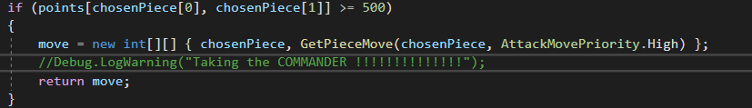
Figure 1
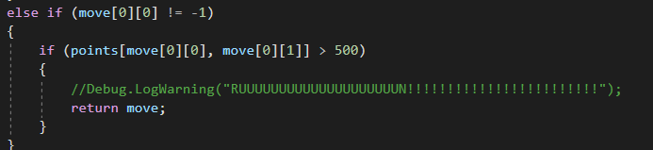
Figure 2
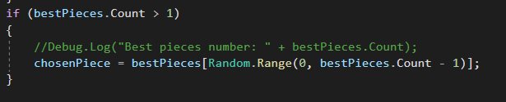
Figure 3

Changes to Utility function
The Utility function faced some changes since I did not consider how piece values were used and how attacking tiles would play a role in the actual value of the piece.
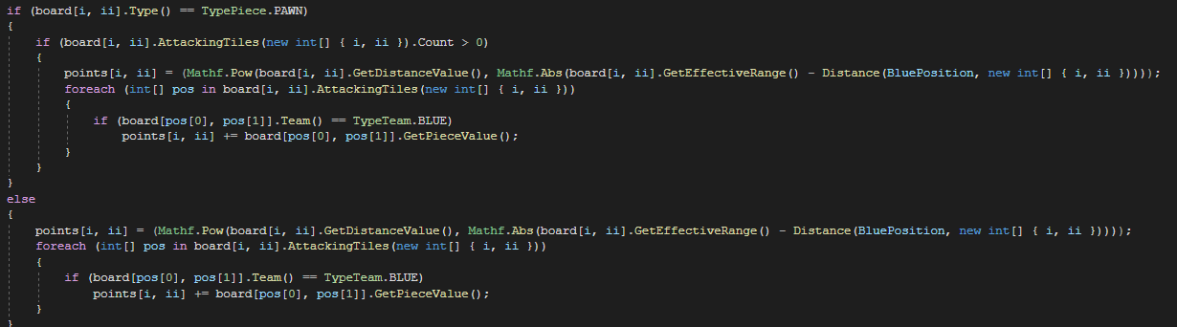
Because of these changes were made to the utility function to value each piece more accurately and to consider the tiles that the piece can attack (as seen blow). Another smaller detail that was needed was the ability for the Utility function to ignore pieces that had no values because they contained no capable moves. This was because once that Pawn piece moves to the other side of the board it becomes useless and is unable to move. Because of that is should not contribute to the utility function because then will have no use.
Figure 4 Updated utility function
This change gives a much more realistic representation of how each player is doing compared to the previous version of the Utility function.
Figure 5 Original Utility function

Game Utility Function
Since the objective of the game is to take the opponent’s Commander a good way to measure the points of the game would be to assign points to each piece and then modify the value of the points according to how close the pieces are to the enemy commander. Most likely what will be needed is a separate value for how each piece is weighted in proximity to the enemy Commander, for the sake of balancing how much each piece is a threat to the enemy. This is because each piece is different in capability and movement speed. A piece cannot contribute negative points to a player.
The distance function for how near the pieces are to the enemy commander will simply use the Pythagorean equation to calculate the distance as in the following:
$$Distance()=\left(\left(pos1\left(x\right)-pos2\left(x\right)\right)²+\left(pos1\left(y\right)-pos2\left(y\right)\right)²\right)½$$
Example of distance equation in action:
Pawn at position B2
Enemy Commander at position D9
B value = 2
D value = 4
$$Distance()= \left({\left(pos1\left(x\right)-pos2\left(x\right)\right)}^{2}+{\left(pos1\left(y\right)-pos2\left(y\right)\right)}^{2}\right)½$$
$$Distance=\left(\left(2-4\right)²+\left(2-9\right)²\right)½$$
$$Distance=\left(4+25\right)½$$
$$Distance=5.385164807 units$$

The Piece point function will determine the value of a piece on the board relative to how far the piece is from the enemy commander, the piece value and the piece distance value. The piece value is a value that represents the cost of losing that piece, in other words the value of the piece. The Piece distance value is a special value that will be used to weigh in how effective the piece is at the distance that it is currently at. The points awarded for the value of each piece will be larger the closer the piece is to the enemy commander and it is because of this that the Piece Distance value is going to be to the power of the distance it is from the enemy Commander and the Piece Distance value can never be more than 1. The equation will be as follows:
PiecePoints = pieceValue * pieceDisatanceValue ^{Distance- effectiveDistance}
For the sake of an example, the Pawn will be assigned a value of 1 point and the distance weight is 0.9 and the distance will be the same one demonstrated before. The effective distance of a pawn is 1
PiecePoints = pieceValue * pieceDisatanceValue ^{Distance - 1}
PiecePoints(pawn at position b2) = 1 * 0.9 ^{4.385164807}
PiecePoints = 0.6300077076
The Function that will count the points for each time will run through each peace of each team and accumulate the total points per team for all the pieces. This should give a rough prediction of which team is winning. There will a maximum predetermined value of a pawn after it is a certain distance behind the enemy commander as pawns do not have the capability to move backwards. This will reduce the inaccuracies in the equations.

